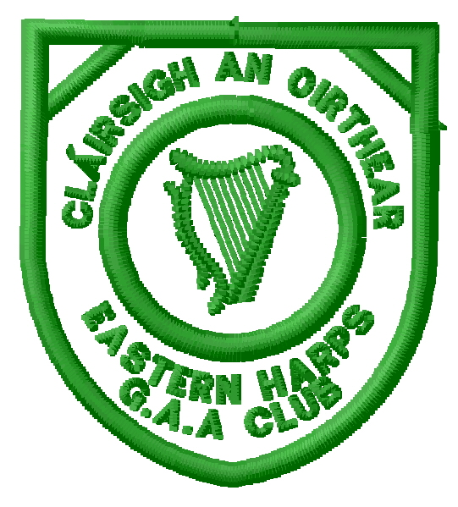
Eastern Harps GAA Club
Annual General Meeting
Executive Committee Nomination Form
Position being Proposed (tick one only; use separate forms for multiple nominations)
Chairperson:
Vice-Chairperson:
Secretary:
Asst-Secretary:
Treasurer:
Other Committee Position
(including Executive Committee Member):

* Nominee (Block Capitals):
* Nominee (Signature):
* Proposed By (Block Capitals):
* Proposed By (Signature):
* Seconded By (Block Capitals):
* Seconded By (Signature):

* Nominee, Proposer & Seconder must be fully paid-up Members and be present at AGM to confirm nomination.
This form should be sent either directly to
Shaun Dorrian, Secretary, Carrowcrory, Ballinafad, via Boyle, Co. Sligo
or a scanned copy (including handwritten signatures) will be accepted by email to secretary.easternharps.sligo@gaa.ie
to arrive no later than Tuesday 7th November 2017

