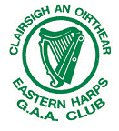
Easter Harps would like to thank their 2012 Premium Sponsors for all their help and support throughout the year

Tansey’s Gurteen

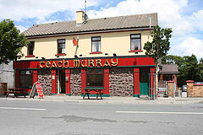

Teach Murray

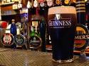


Mac’s Bar

The Traveller’s Rest

James Duffy & Co. Accountants

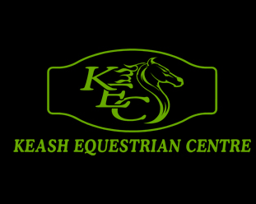

O’Dowd
Transport

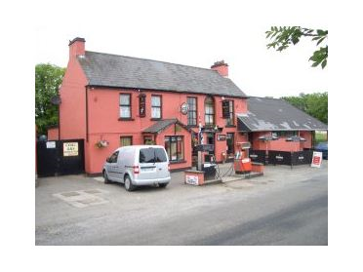
DRURY’S BAR, MONASTERADEN

