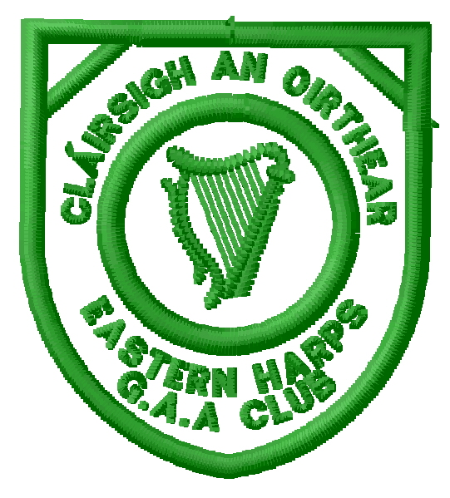
Eastern Harps GAA Club
Executive Committee 2018
Chairperson | Padraig Henry
Vice Chairpersons | Tom Murray
Secretary | Shaun Dorrian
Vice Secretary | Avril East
Treasurer | Thomas Cryan
Vice Treasurer | Brendan McHugh
PRO | Kevin Cryan
Delegate to County Board | Ciarán McGovern
Schools Liaison Officer | Fintan McGowan
Coaching Officer | Brendan McHugh
Childrens Officer* | Deirdre Gillen
Registrar | Deirdre Gillen
Ladies Chairperson | Claudia McGovern
Ladies Secretary | Aisling Stephenson
Ladies PRO | Lisa Casey
Development Officer | Sean Scott
Health & Wellbeing Officer** | Carmel Taheny
Pitch Committee Chairperson | John Cryan
Oifigeach na Gaeilge | Lisa Casey
Bord na nÓg Chairperson | Seamus Hannon
Senior Player Representative | Kevin Cryan
Club Safety Officer | Barry Cryan
Insurance Officer | Tom Murray
Executive Members: Liz Coyle, Louis Carty, Jimmy Casey, Rachel Cryan, Colm Duffy, Paul Dwyer, Gabriel Gallagher, Ronan Higgins, Paul Judge, Edel McNulty.

* In accordance with GAA rules, the position of Childrens Officer is nominated by the outgoing Executive and ratified at the AGM.
** In accordance with GAA rules, the position of Health & Wellbeing Officer is a 2-year term. The 2019 year will be the 2nd year of this term.

